1. In next lecture, we will be using Java Based Configuration.
2. Well, it is important to understand that how to create a **Java Based Configuration in a Spring Application**.
3. **@Configuration**:
   1. When we annotate a class with @Configration, that class becomes a **Java Based Configuration** and within that class we can define Spring Beans.
4. **@Bean**:
   1. In order to create Spring Beans, we need to create methods annotated with @Bean.
5. **ApplicationContext**:
   1. Then we create Spring IoC container by instantiating ApplicationContext Object.
6. 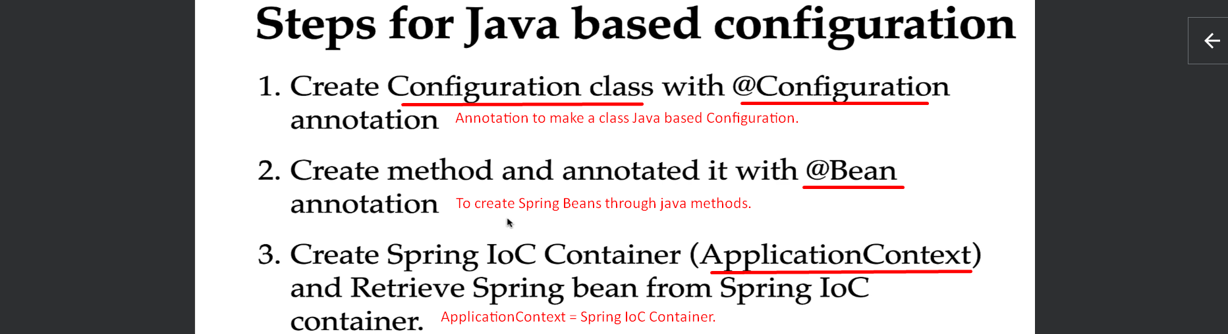
7. 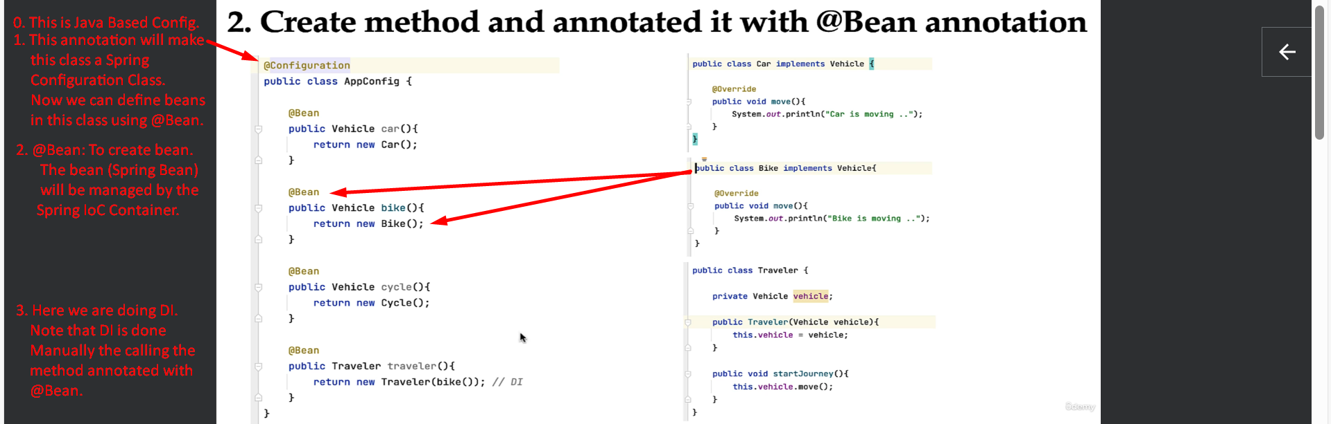
   1. In the above slide, the last line code where we are doing DI, calling this method will not create a new Bike instance rather earlier managed object will be referenced.
8. 